**JASPER SERVER DEPLOYMENT WITH ECLIPSE**

* First you open and launch eclipse environment. Make sure you have installed JVM, JRE. 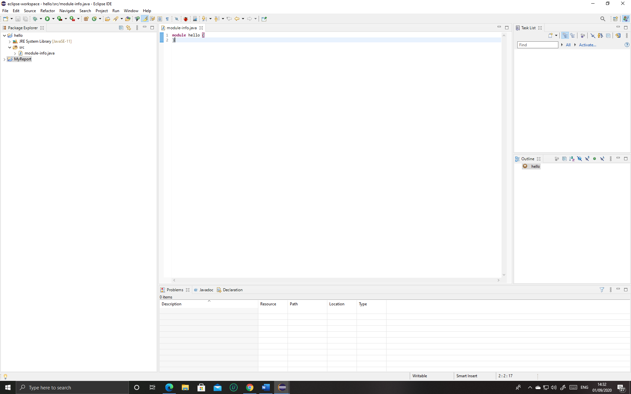
* Then go to eclipse market place from help in the toolbar and search for jasper studio in search box. 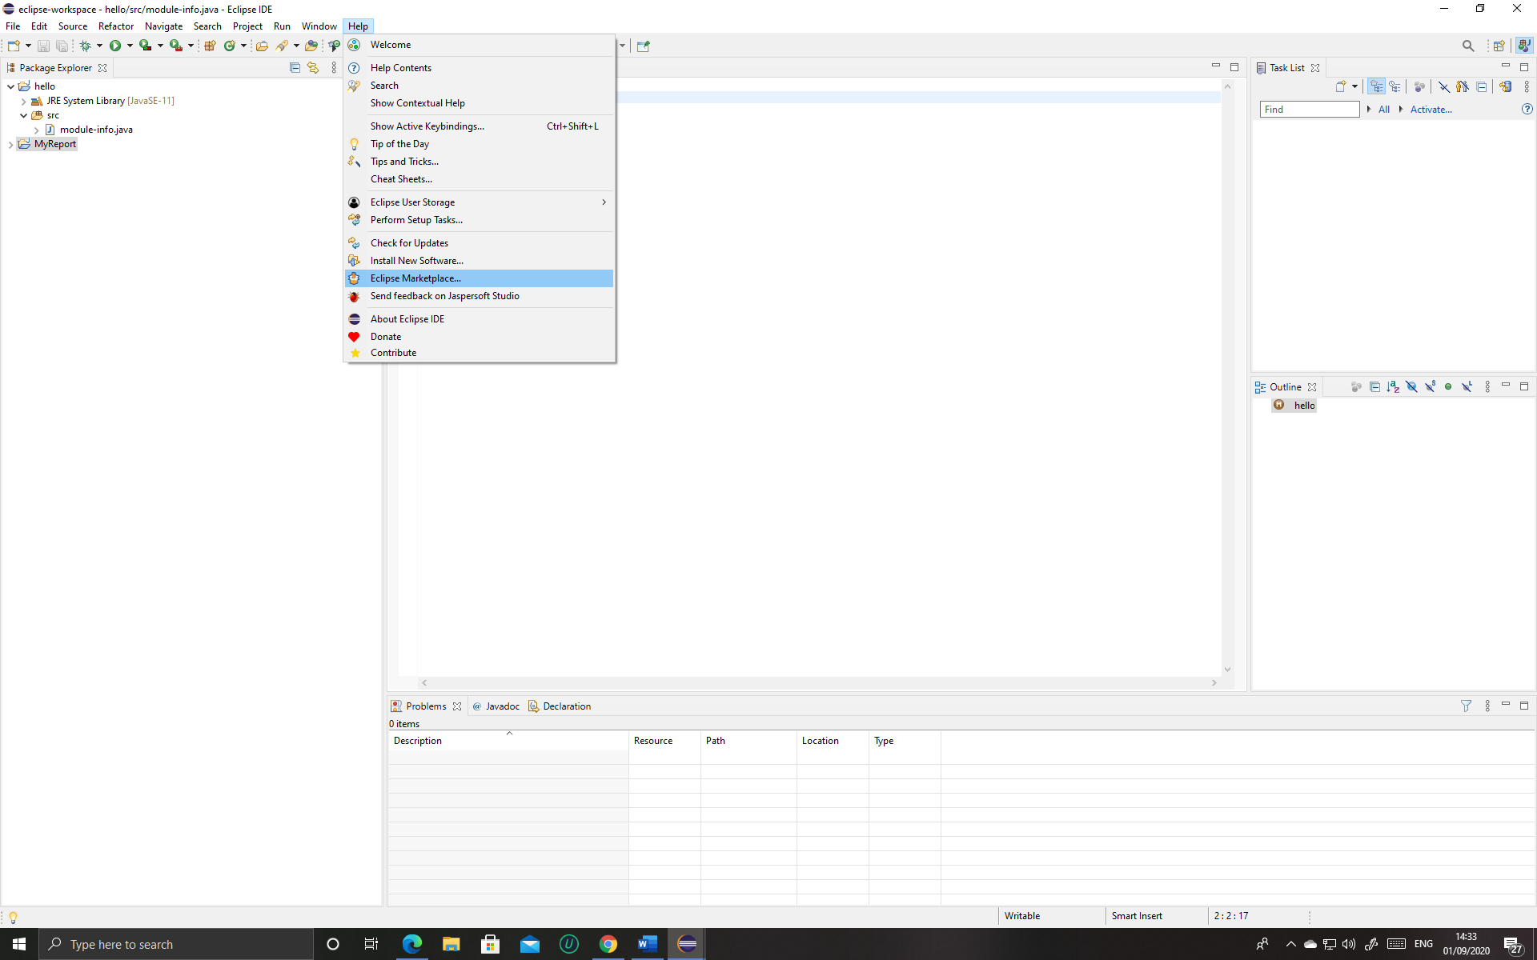

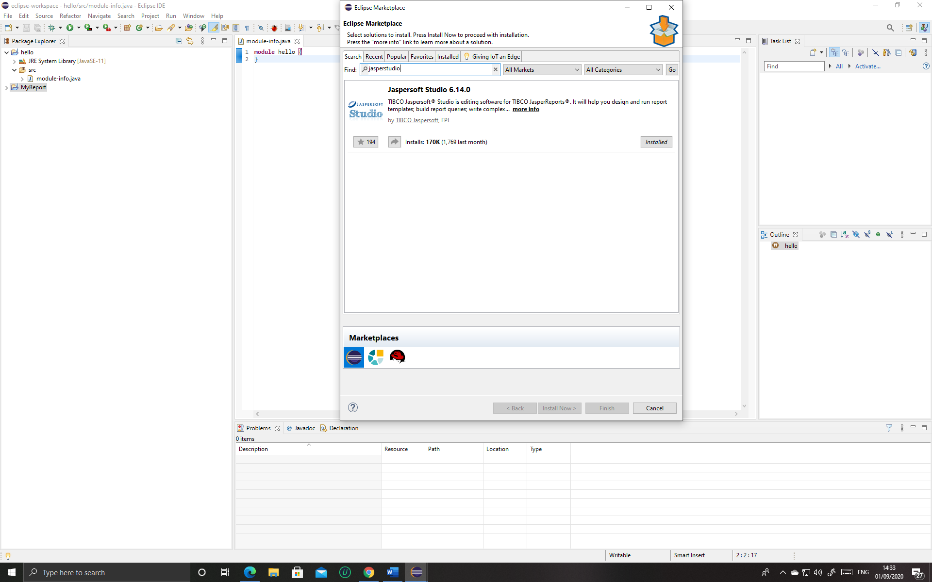

* When you have installed jasperstudio the option to use it will be given when you will go to File -> New -> Jasper Report, but **firstly make a new java project after that you can make a jasper report otherwise you cannot make a Jasper Report.**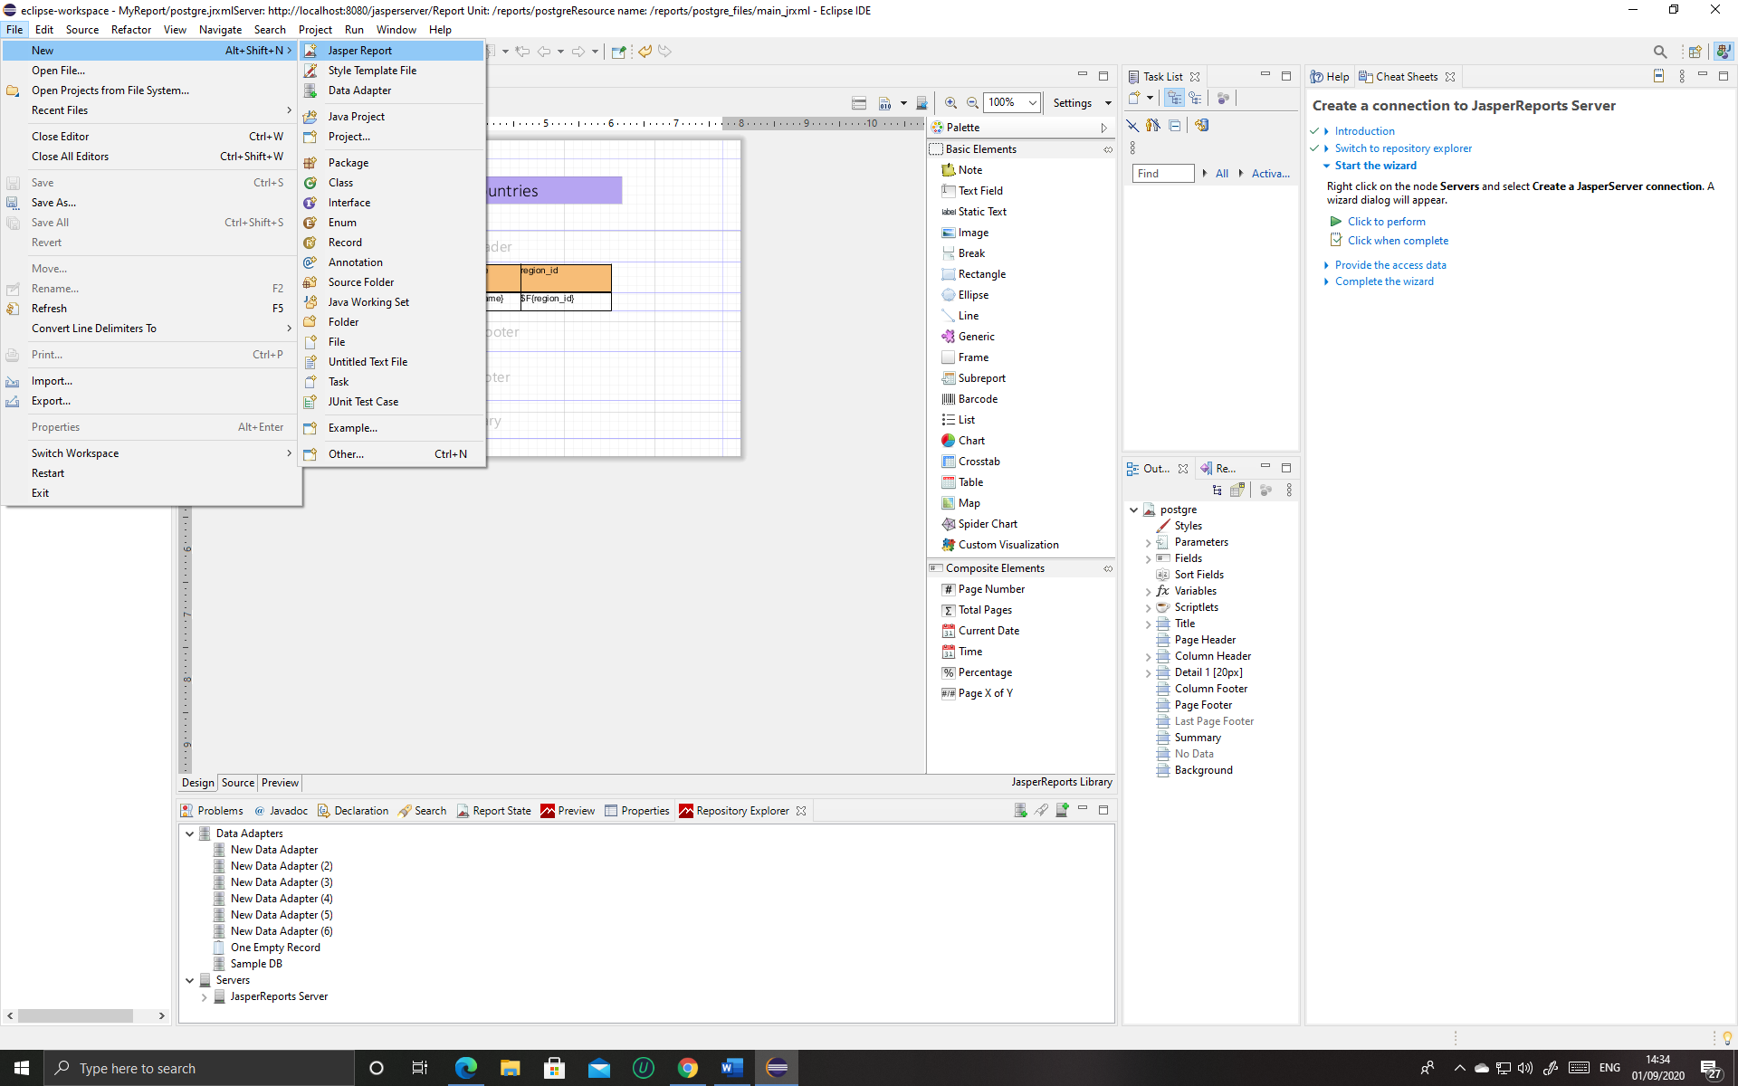
* When you click on Jasper Report numerous options will be given, choose the Blank A4 option, then after that change your report name if you want to.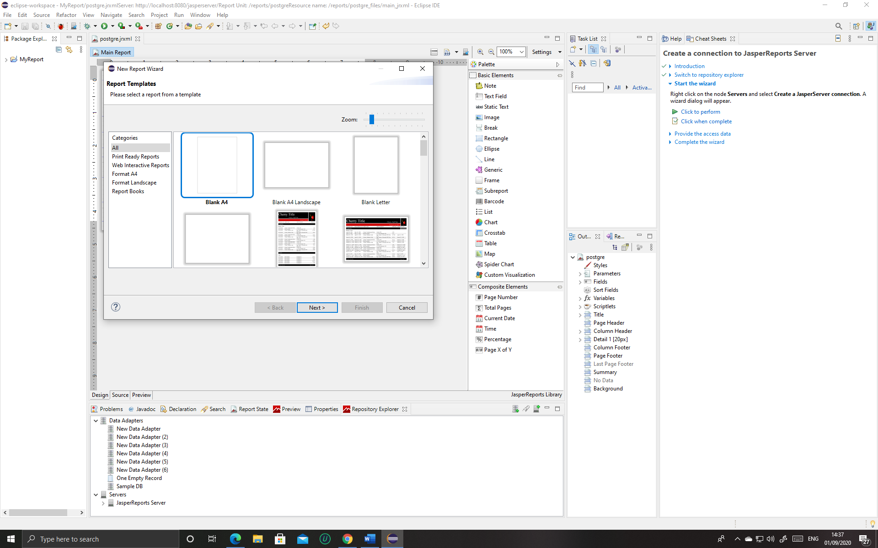

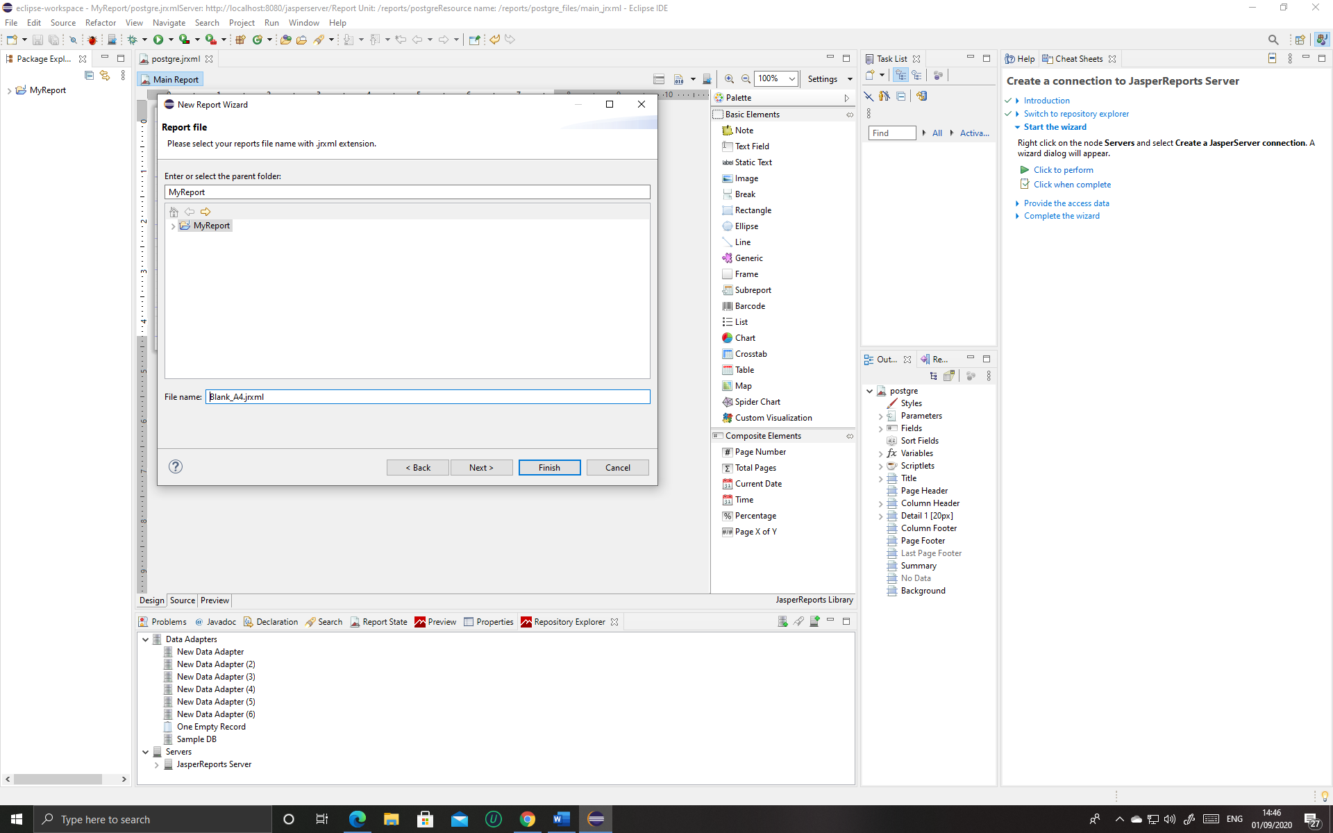

* After naming you report a new window swill appear asking for a data source connection. In the data adapter there is now connection means it is empty, go to new Select your choice of DB for PostgreSql you have to choose database JDBC connection.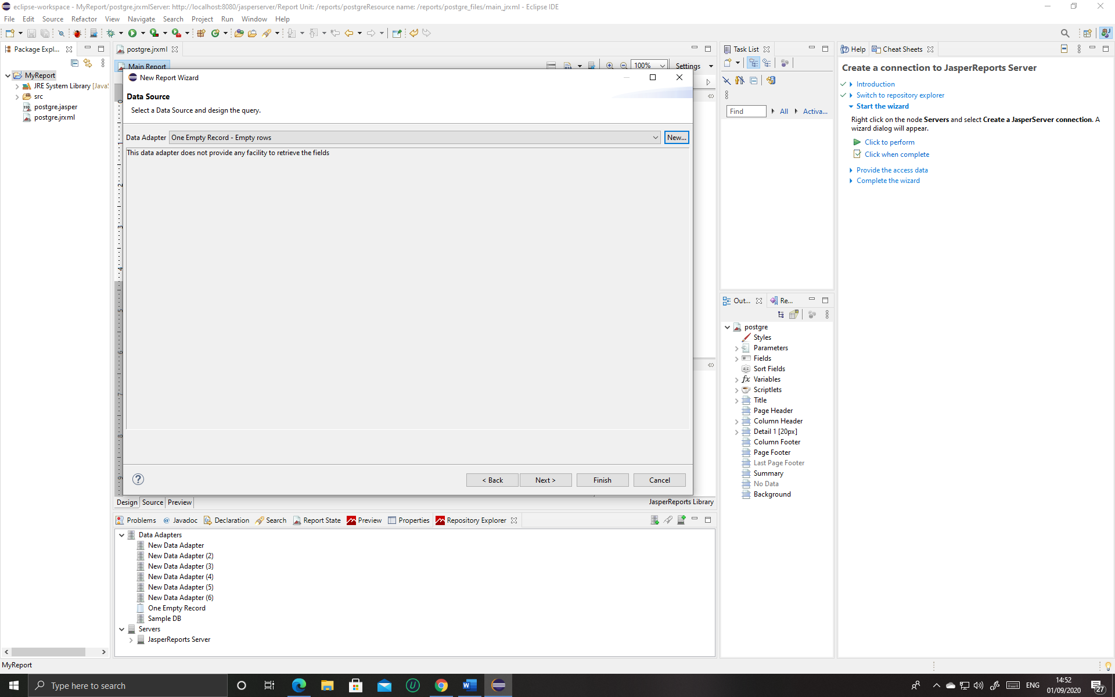

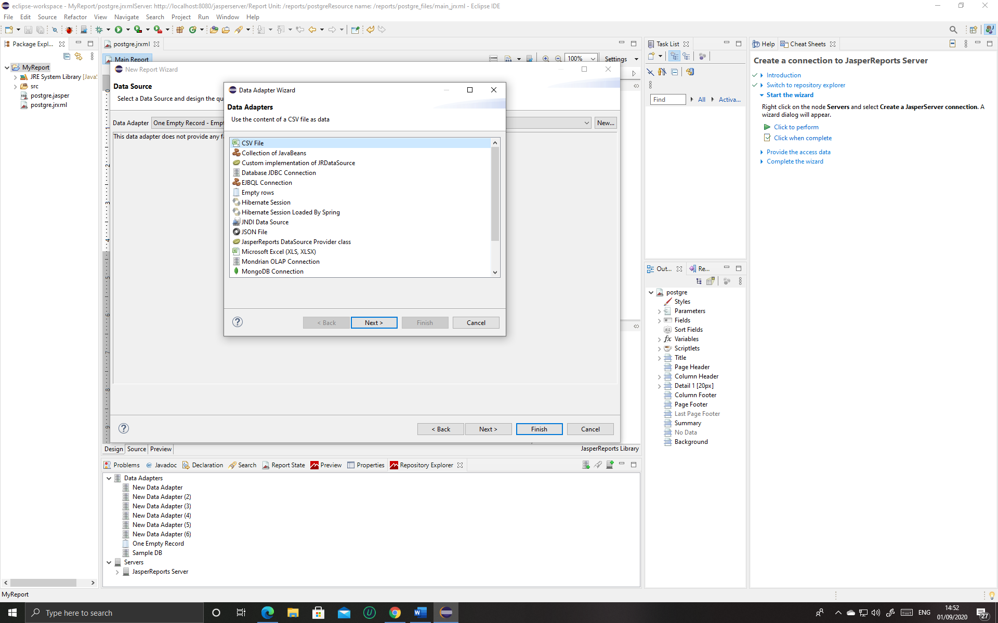

* After selecting the connection then the data adapter wizard will show the name of your adapter you can give any name then below the name there four important things because this is where you will connect your database. Give the JDBC driver connection to PostgreSQL as we are using PostgreSQL. In JDBC URL the postgre url will automatically appear but you will have to use the name which your PostgreSQL is means remove the database that is default name given so change it, my database name is postgre so change the name in the URL. After that I’ve the Username and Password. I have given the same as my PostgreSQl. 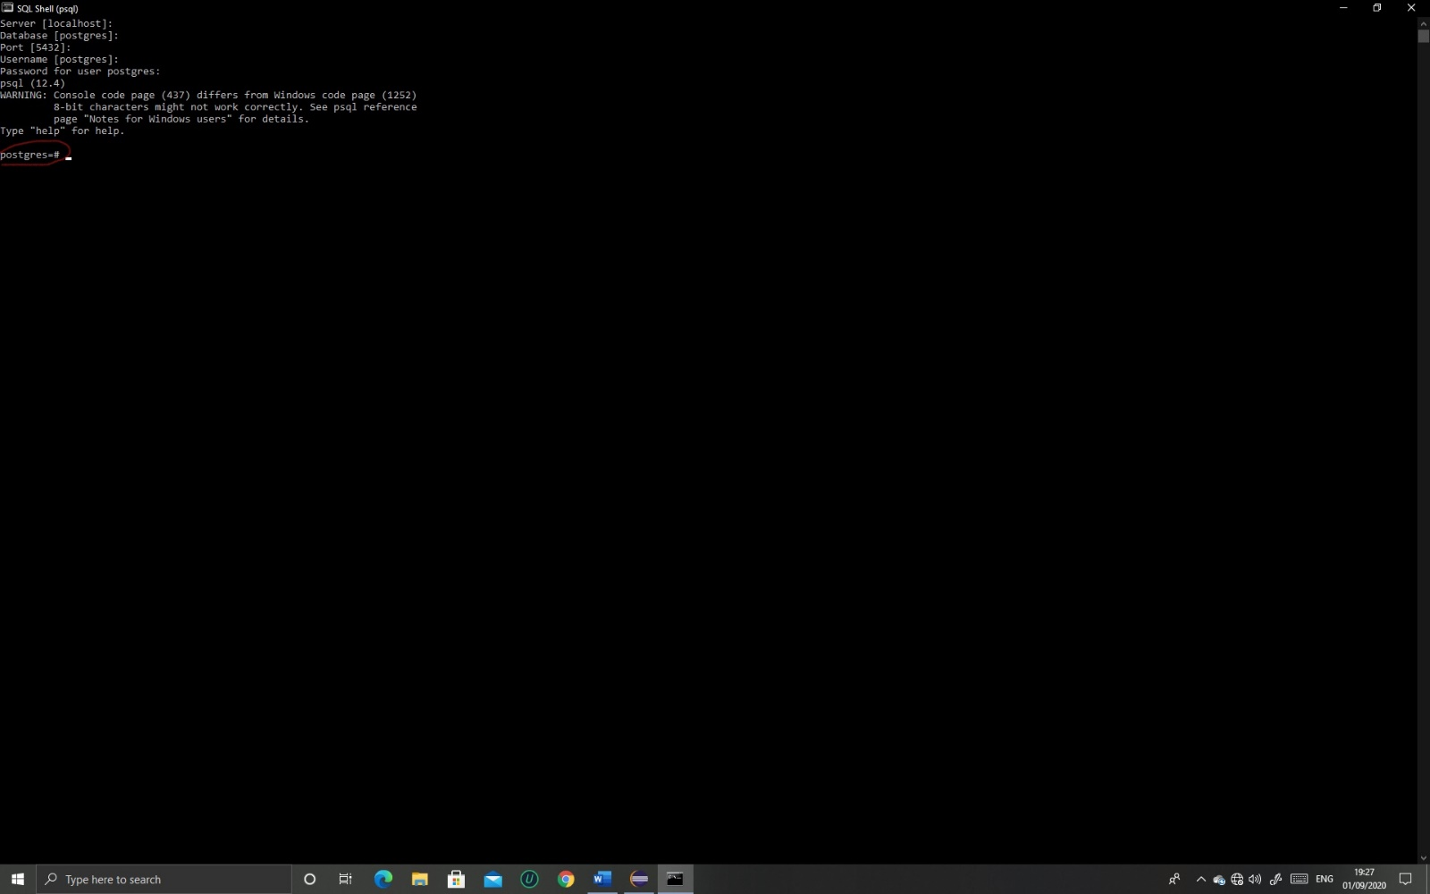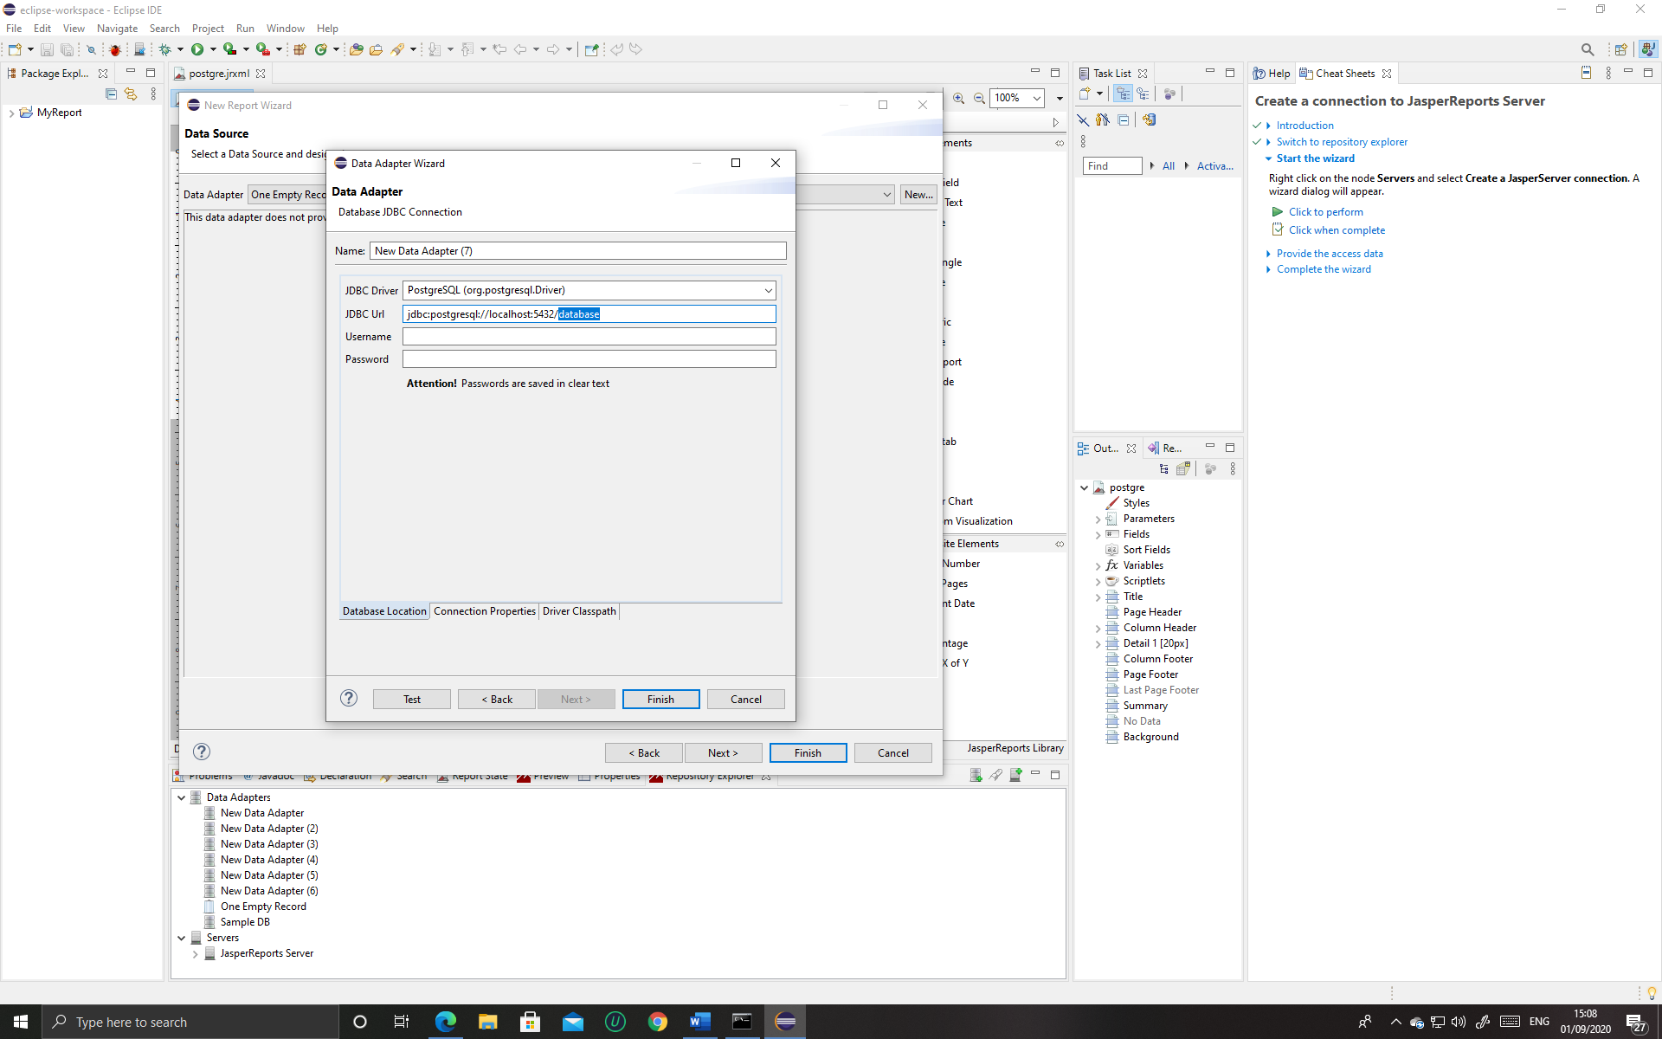

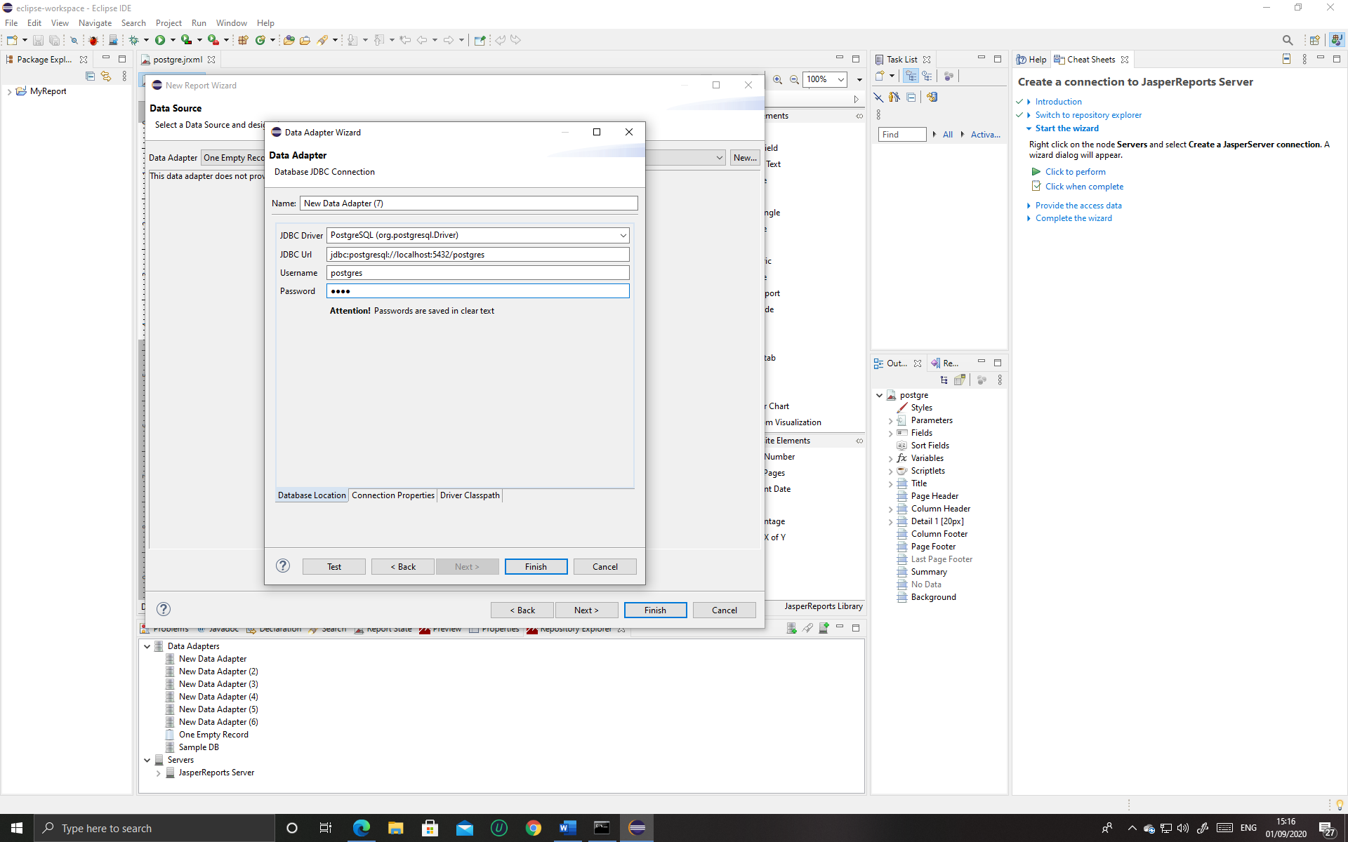

* Then the connection will be given a all the details will be shown in the new window’s left box and in the right box write which table you want to select **you can only select one table**. After selecting a table, the fields will be given, after that you can start making your report.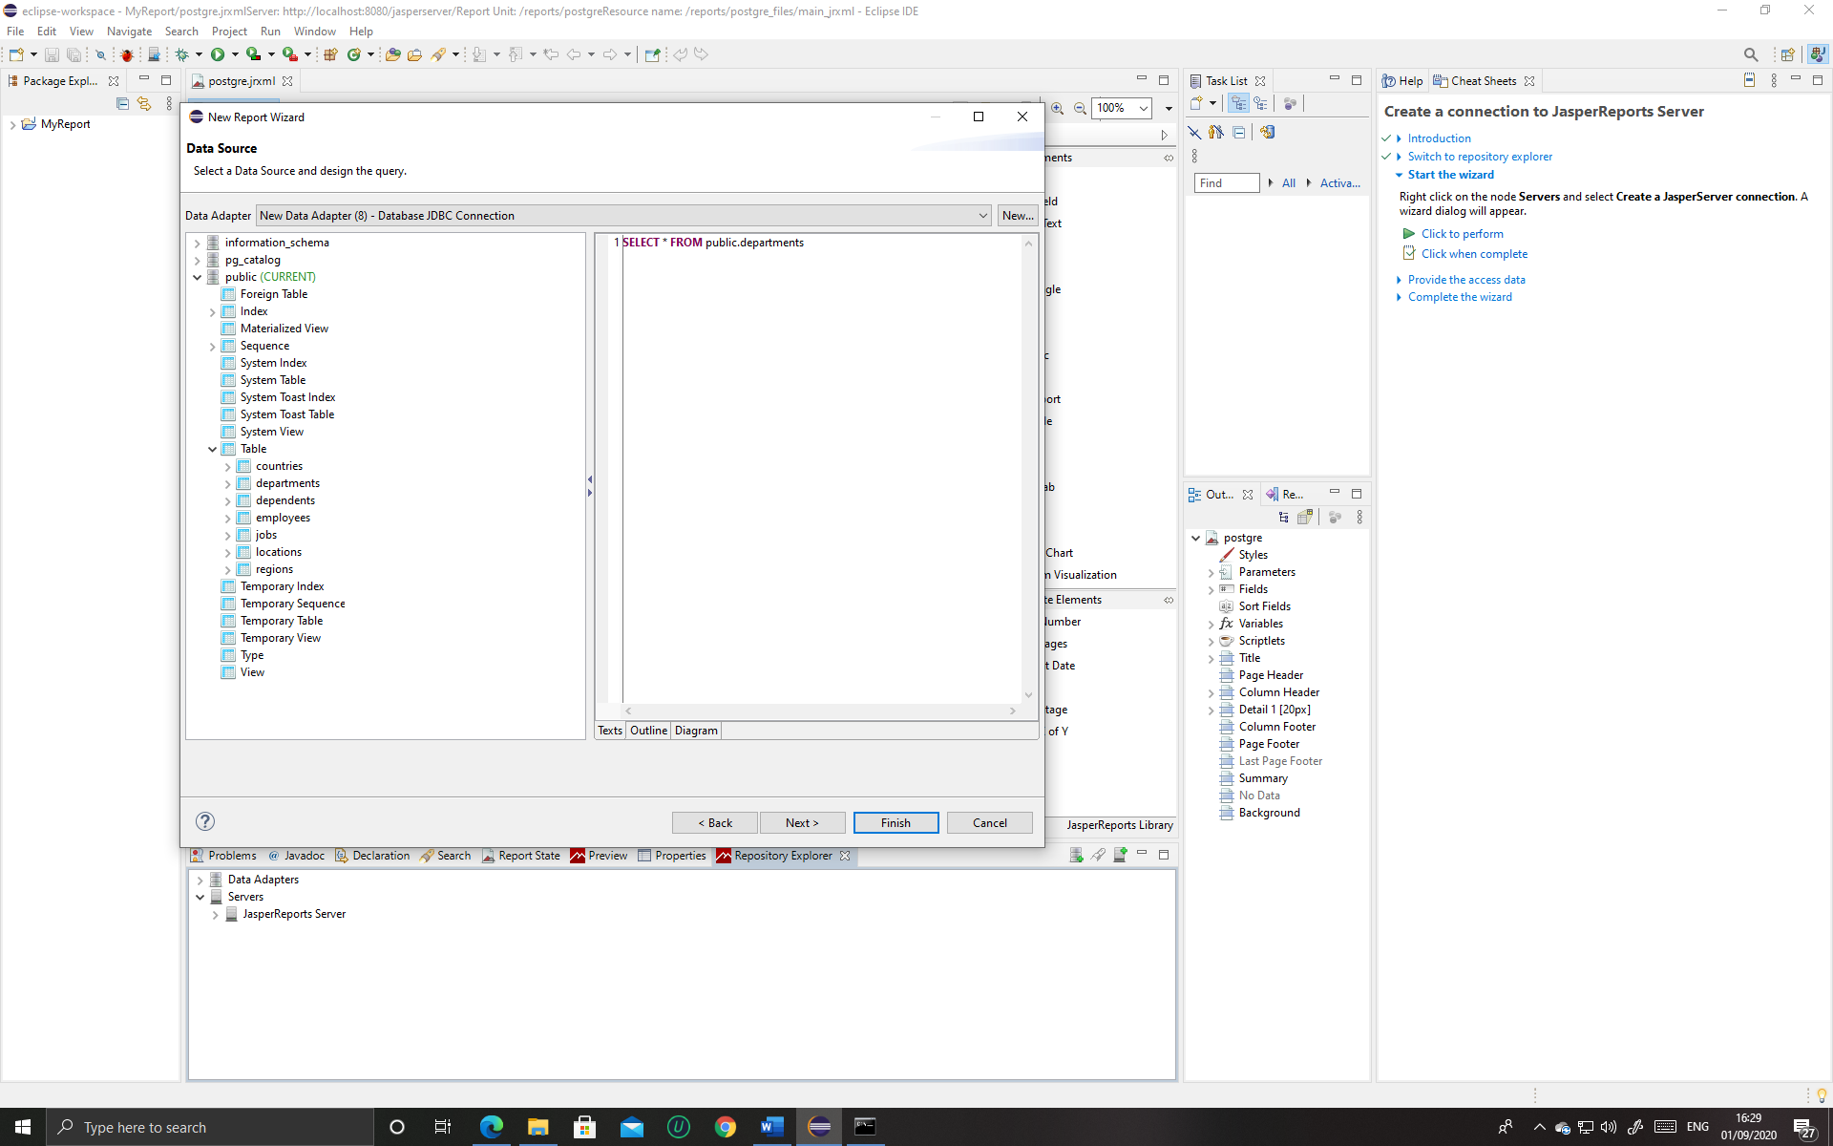

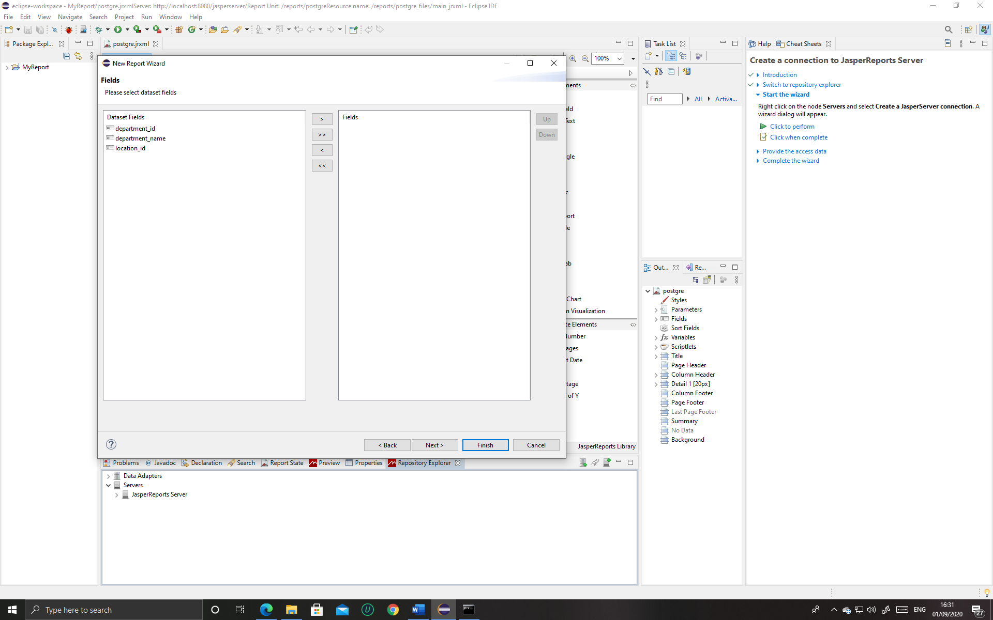

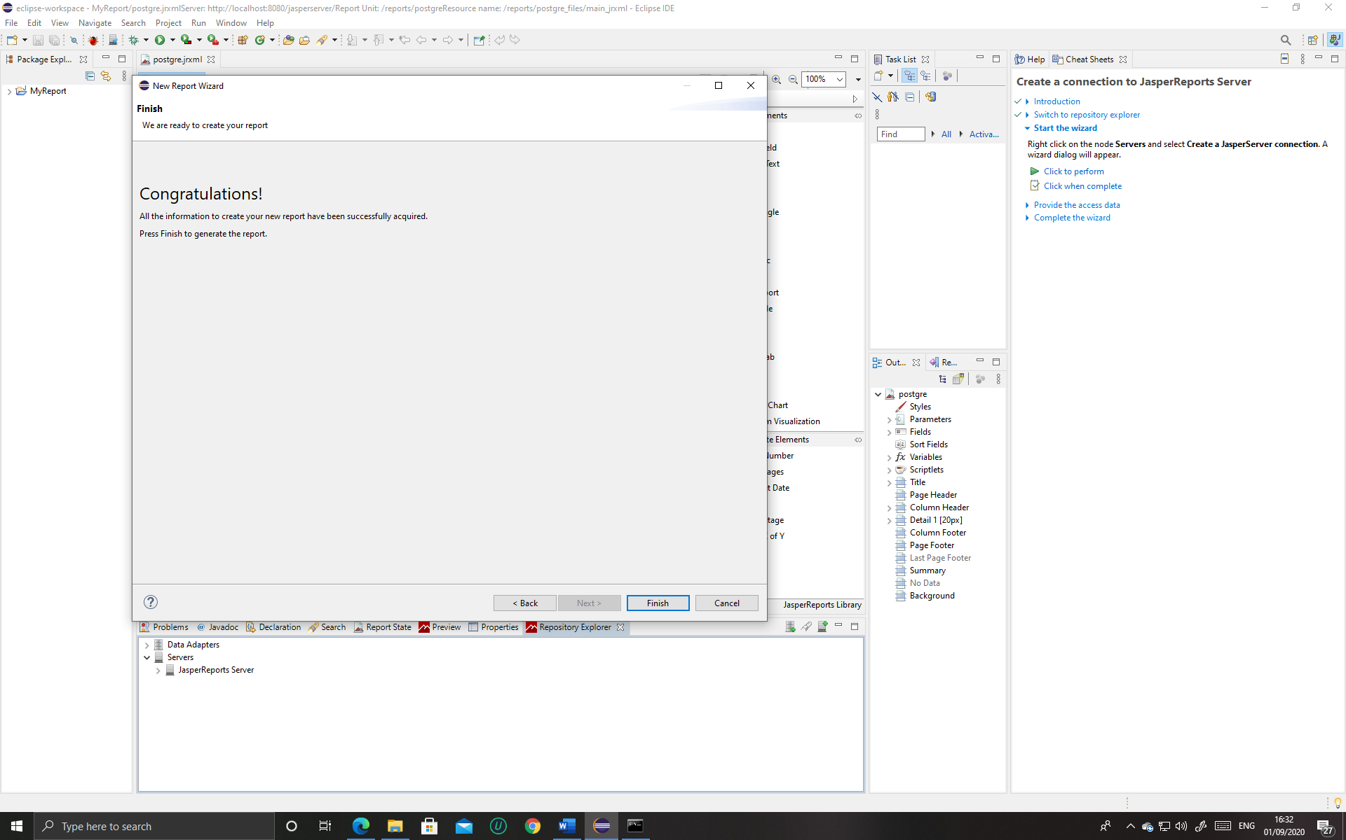

* Then go to dataset and query editor dialog to add fields if there are no fields showing first, after that a new windows will appear, there click at the read fields then the fields will be given below and then click ok.

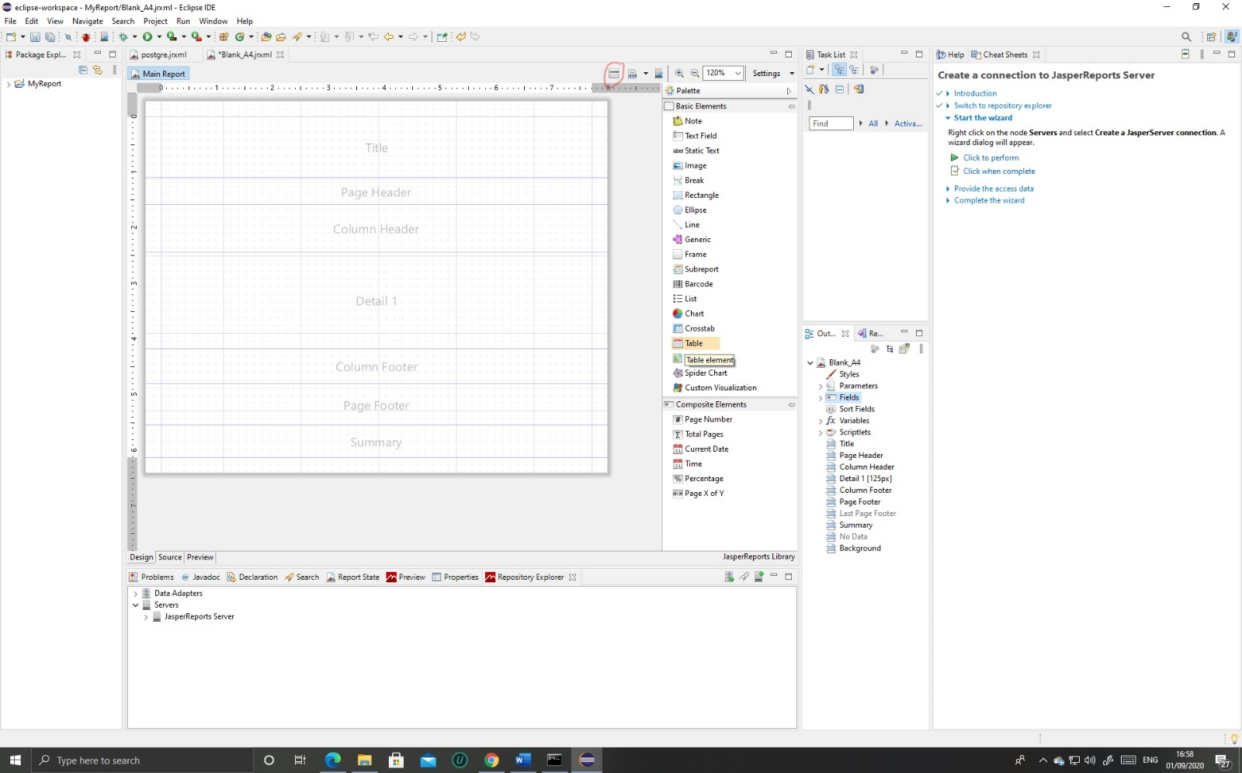

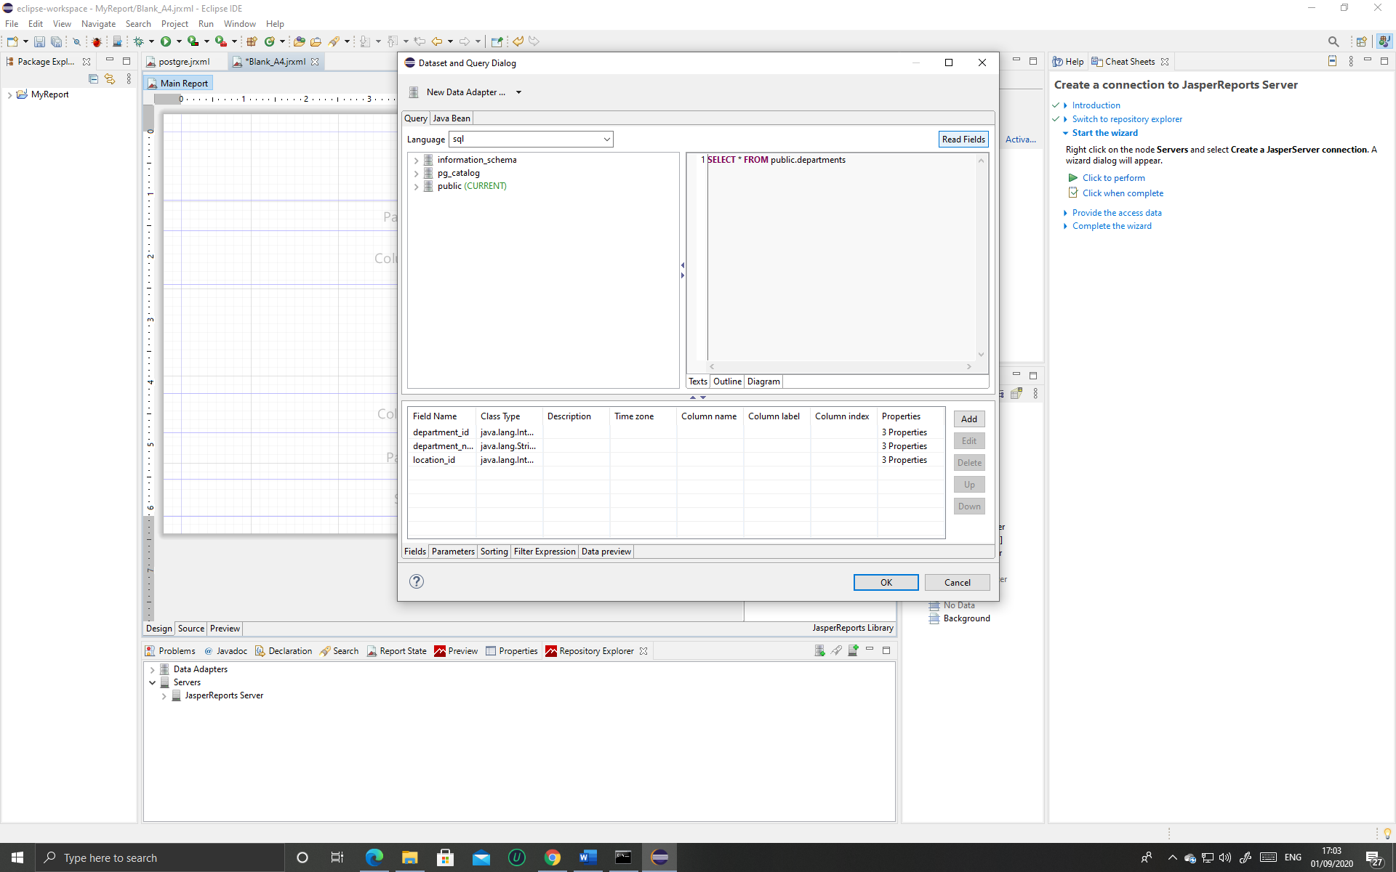

* For deploying your report on to Jasper server you firstly have to create a server located in repository explorer

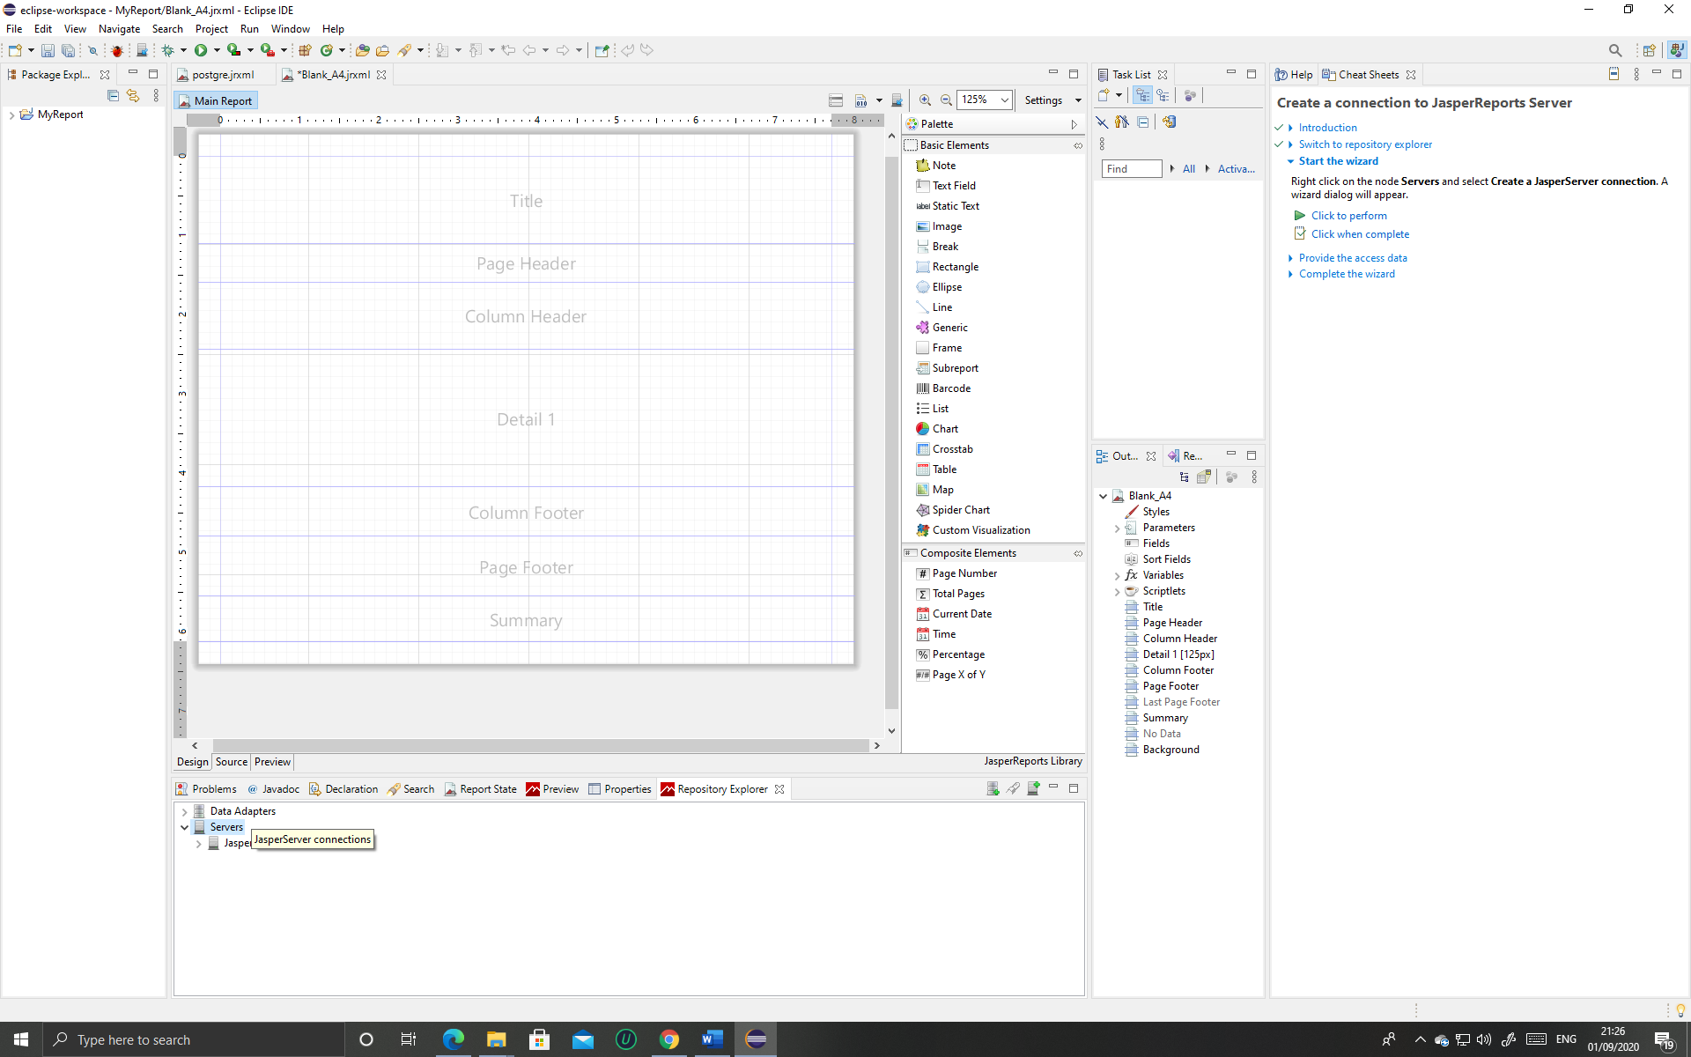

* Make sure you are logged in to jasper server

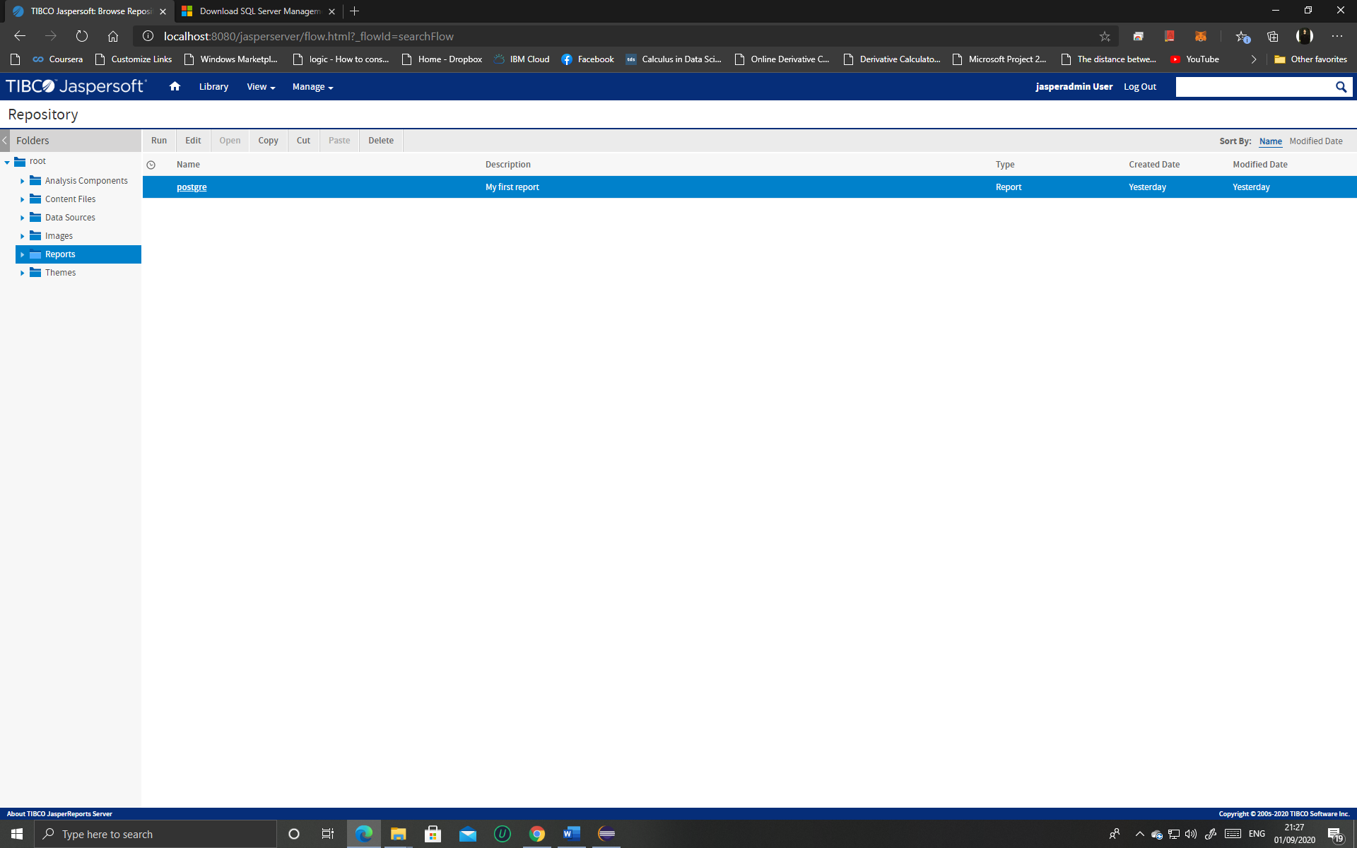

**LINKS:**

<https://community.jaspersoft.com/download> ( To download jasper server )